Name: |  | Course:
UCAS Checklist | Date to be Completed
UCAS account set up
Initial selection of courses listed
Personal statement started
Draft personal statement sent to Employability Coach
Final Personal Statement Draft completed
UCAS applications ‘sent’ to Co-ordinator and Application Fee Paid
Key Deadlines
15 October 2020 | Deadline for applications to Oxford/ Cambridge and most courses in medicine, Dentistry and veterinary medicine/science.
15th January 2021  18:00 (UK TIME) | Final UCAS deadline
25th February | Extra Opens – applications who have used all 5 choices and are not holding any offers, may be able to add another choice in Track.
30th June | Applications received by this deadline will be sent to universities and colleges. After this time, applications are automatically entered into Clearing.
4th July | Last date to add an Extra choice in Track
4th July | Clearing opens for eligible applicants, and vacancies are displayed in UCAS search tool
19th August | Adjustment opens for registration
** September | Last date to submit 2021 entry applications

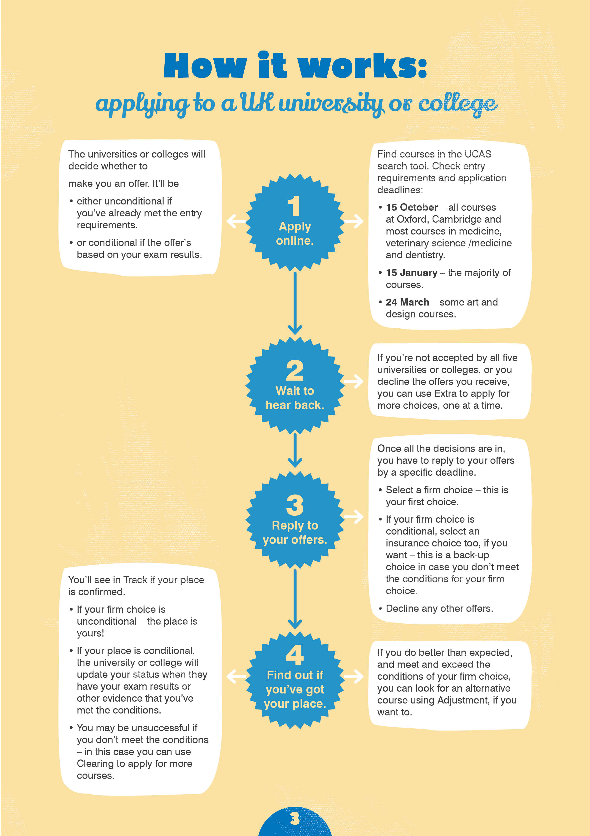

Selecting a University and a Course
You can choose up to five courses to put on your UCAS application, and ultimately you will need to choose to accept two: one as your first choice; the second as an ‘insurance’ offer in case you do not gain the grades required for your first choice. Work your way through the following questions by ticking the appropriate boxes, so that by the end you have a more focussed set of priorities to use when searching for a course. You might also want to discuss these questions with your Course Tutor, Careers Advisor and/or a parent or carer.
Section 1 | Subject
What subject/subjects do I think I want to study?
1st choice
2nd choice
3rd choice

Section 2 | Type of Course Please place an X in the box
What type of course do I want? | Yes | No
Single degree subject
Joint degree subject
Sandwich course with a year out in industry or a year abroad
3 year Bachelor degree course
Foundation Degrees.
HND course

Section 3 | Assessment Structure Please place an X in the box
What type of assessment suits me? | Yes | No
Assessment over all course
End of year exams
Mixture of 2 systems

Now refer to www.ucas.com and find the universities that offer the subject and type of
course you are interested in studying. If the number is relatively small (12 or fewer) add the
names of the universities and courses to the table at the end of this section.

Section 4 | Location Please place an X in the box
Where do I want to live? | Yes | No
At home
Away from home

If living away from home:
How often do I want to go home? | Yes | No
Each weekend
Once a month
During term time reading weeks
At end of terms only
At end of year only

How close to home do I want to be? | Yes | No
Want to be within easy reach - 1 hour travelling distance from home
Want to be within 2-3 hours travelling distance from home
Want to be OUT of easy reach of home.

Now refer to http://www.opendays.com/search
where you will find a university location map,
and find those institutions that suit your
location needs.

Section 5 | Institution Please place an X in the box
Does the ranking of the university/course matter to me? | Yes | No
Top Ranking university (e.g. Russell Group)
Course ranked highly in league tables

Does the cost matter to me? | Yes | No
Tuition fees less than £9250/annum
Bursaries available to reduce tuition/maintenance costs
Low cost of living – geographic location with cheaper accommodation/transport
Commutable distance to avoid accommodation costs

How large an institution would suit me? | Yes | No
Large institution, perhaps on a number of different campuses
(think about how you are going to get to different areas)
Smaller institution with one central campus

What campus type? | Yes | No
City (shops, facilities, night life etc.)
Town (smaller, pubs, societies etc.)
Country – self-contained within its own grounds, possibly outside nearest population centre (entertainment is student/union based on campus)

What student accommodation do I want? | Yes | No
1st year in halls
Student accommodation in 2nd year
Student accommodation for final year
Food provided in cost of accommodation
Self-catering units to use
Don’t want student accommodation (think about price and location if no student accommodation available)

What transport will I use at university? | Yes | No
Walk/cycle
Reliable bus/train service
Own car (think about cost and availability of parking)
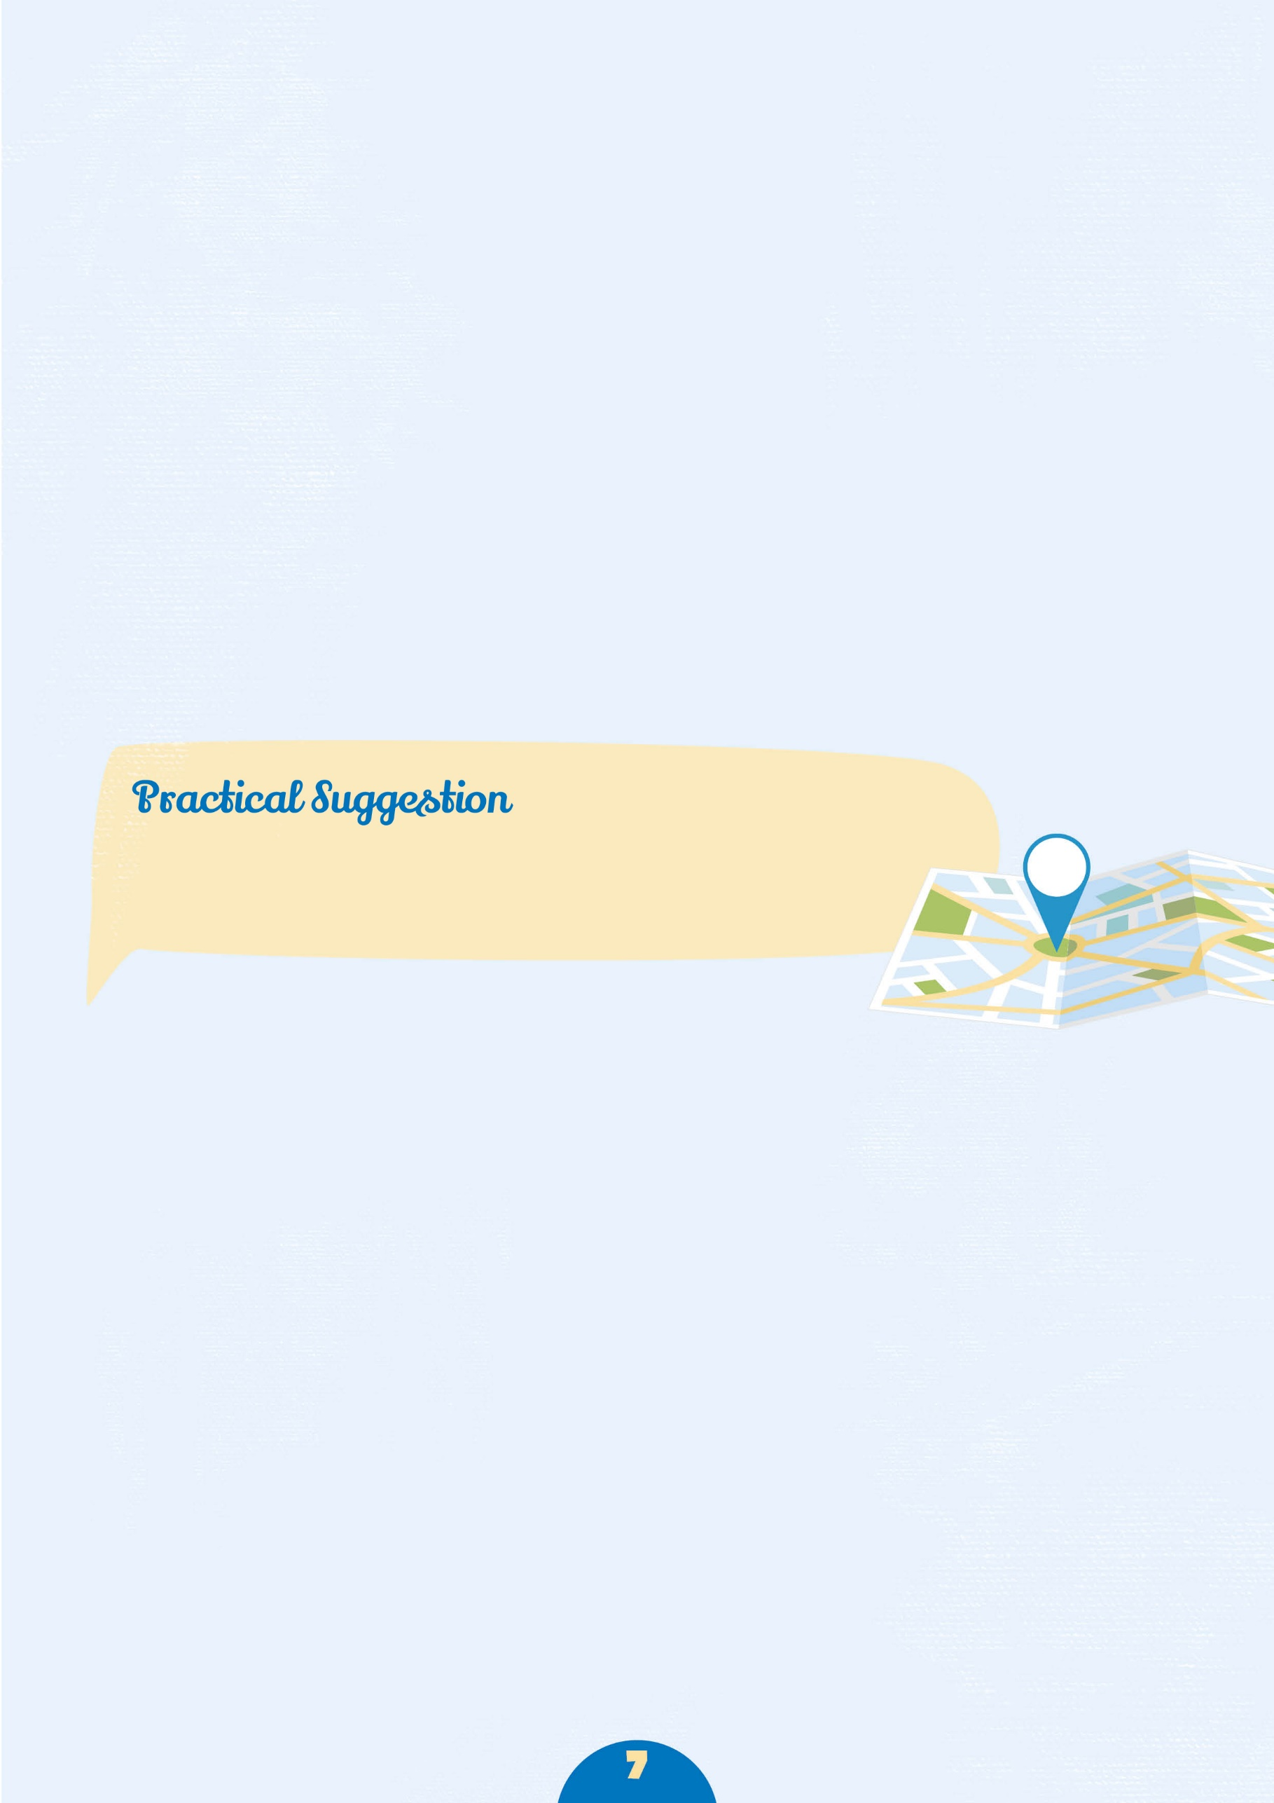
What sort of fellow student do I want to study with? | Yes | No
Male orientated (Aston Uni has a 6/1 male/ female ratio)
Female orientated
Large intake of international students
Large intake of mature student
Large number of different courses studied

Now refer again to the university location map; http://www.opendays.com/search
and check out the websites of the universities you have already
identified and narrow your choice.

Section 6 | Entry Qualifications
Use www.ucas.com and the websites for individual university courses to find out the subjects and grades required.
For each course answer the following questions:
Can I achieve the entrance qualification for this course? | Yes | No
Will they accept my current qualification?
Am I studying the right subjects for this course?
Am I capable of achieving the required grades?
Did I achieve the minimum GCSE grades
(courses often have a minimum Eng/Maths/Science requirement)
Do I need to submit a portfolio of work?
Do I need to sit an entrance exam?
Do I need to attend an interview?
Do I need relevant work experience before application?

Section 7 | Employment
Use the websites of individual universities and research their destination data. Try to find out what percentage of graduates from the course which interests you found employment, and what form did this employment take? If you struggle to find this information, telephone or email the university – by law they must publish this data.
Will this course give me a good chance of finding employment? | Yes | No
Are most graduates from this course in permanent employment?
Do the jobs undertaken by graduates interest me?
Do graduates go on to study for higher degrees (Masters, PHDs)

Further questions to think about:
? What facilities are there on campus: shops, banks, medical centre, sports, etc.?
? Do you have a hobby that you would like to continue at university? What sports
and societies are available?
? Are there opportunities to get a job to help with finances?
? How many hours a week will I be in timetabled teaching? What size are tutorial groups?
? Do most students stay on campus at weekends?
? What career guidance facilities are there/job fairs etc?

Getting Information

- Prospectuses – online and small selection of hard copies in the Careers & Employability Hub.
- www.ucas.com
- Student forums
- Speaking to the current L3 Y2 students about their applications
- Asking Course Manager’s for advice/information
- Using any specialist guides available for particular subjects
- ‘Which University’ a Student Guide
- League tables – use with caution and always refer to more than one!
  - www.thecompleteuniversityguide.co.uk/league-tables/
  - www.thetimes.co.uk
  - www.guardian.co.uk
  - www.telegraph.co.uk
  - www.independent.co.uk
- Attending open days – a full list of these can be
found on www.opendays.com

Section 8 | Shortlisting
Now that you have begun to identify your priorities, use your research to make a list of a maximum of 12 courses in which you are interested and which meet your requirements, and add them to the table which follows.
Remember to try to include a range of entrance requirements including some which are below your predicted grades so that you have some suitable insurance choices later on.
University | Course Name | Course Code | Entry Requirements | Notes
UCAS Applications – Get it Right!

Form filling can be complicated. Use these tips to make sure you get it right!

Put the correct course code in for your choices.
- You choose these from drop down menus.
- Check the details in the UCAS Directory before you commit.

Include necessary details.
- Include required details in the ‘Further Details’ section of the form.
- When you have made your decisions you must use the UCAS Directory to get the institution code, the course code and it will tell you if further details are required. It includes choices of subjects within combined degrees, or specialisms within subjects.
- If your course has any sort of symbol beside its name (*, ^, etc.) check what that means at the end of the institution entry and if it requires further details, put them in.

Fill in the ‘Student Support Arrangement’ correctly.
- Most students should enter the code 02 in the ‘Fee Code’ section.
- The ‘Student Support Arrangements’ section requires you to fill in the name of your County Council LEA. Even if you are sure that your parents will have to pay the tuition fees, you must still fill this in. No British national pays the full tuition fees, which are 3 or 4 times the figure identified as the tuition fees.
- Your LEA will also calculate your student loan.

Fill in the ‘Education’ section correctly.
- In addition to filling in all the correct information about your GCSEs you are required to disclose all certified qualifications in this section.

- Regarding your current qualification in most cases you will be selecting:
  - City & Guilds L3 Advanced Technical Extended Diploma (1080 – first awarded 2019)

There will be variations to this.
  - If you are studying the 720 award, you would pick the same qualification as above but (720 – first awarded 2019)
  - Sport & Public Services – The majority of you will select Pearson BTEC Extended Diploma (QCF)
  - Motorsport – IMI Diploma in Motorsport Vehicle Maintenance & Repair

Please check with your Course Manager if you are unsure of the correct title of your qualification.

Fill in date of birth and age correctly!
- Remember, it should be the year you were born not the date of application.

Get the ‘awarding body’ correct when you record your qualifications.
- If you have done GCSEs at another school, you will have to dig out your certificates.

Complete your personal statement on Word first before updating it to the UCAS website.
- The UCAS website does not like any type of formatting (tabs, indents etc.) so just write line by line.
- Always print preview and print your form before sending it.
Personal Statement Activity – Getting Started

Course Choice
Why have you chosen your courses?
Are most graduates from this course in permanent employment?

Type here…

What have you enjoyed learning about in your current subjects?
Of which pieces of academic work are you most proud? Any particular assignment or module that you have a particular interest in?

Type here…

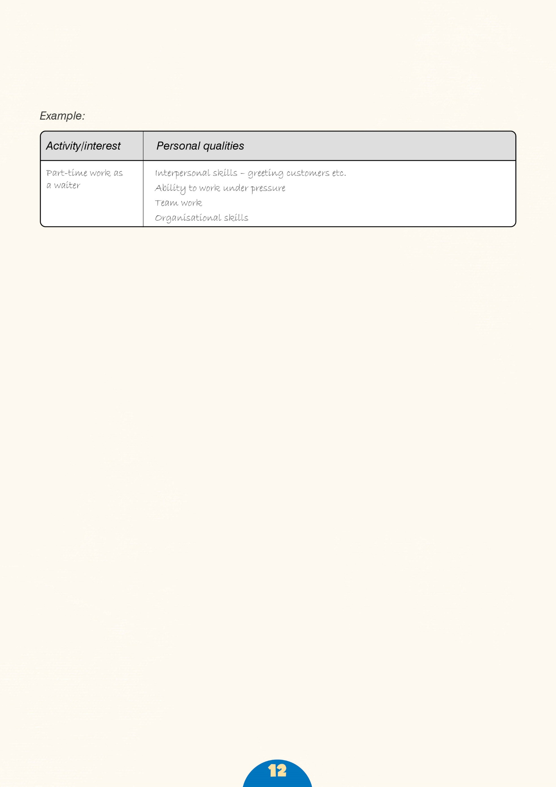
Extracurricular Interests

This is often the easiest section of the PS to write. List your extracurricular interests and achievements in the table below and decide which of your personal qualities each one best illustrates.

Activity/interest | Personal qualities
Work Experience
Now do the same for your work experience. Explain what your role was/what you learnt or enjoyed and skills you have developed.

Placement | Explain your role. What did you learn/enjoy?  What skills did you develop?
Academic Skills
The table below contains a list of academic skills. Think of examples you could use in your PS to show you have these skills. Examples may most easily be found from your current course but consider your work experience and extra-curricular activities as well.
Skill | Example
Analytical thinking
Ability to express ideas
Imagination/ creativity
Independent thinking
Presenting a logical argument
Initiative
Practical skills
Work ethic/ industry
Organisation
Meeting deadlines
Team-working
Self-motivation
Self-discipline
Communication
Listening
Working independently
Research skills

Academic Interests
This is the most important section of the PS, but can be the hardest to write. In the table below, list things that have stimulated your academic interests. For each include a few examples explaining how your interest developed.
Example | Effect
Open Days and University Visits
Use the table below to make notes about Open Days which you have visited.
Institution | Course details | Accommodation | Positives | Negatives

Procedures for Application to UCAS
IMPORTANT – you do not need to complete your UCAS application in one sitting. You can save and edit it as many times as you like before you send it.
1: Registration
- Use the web address (www.ucas.com) and click on Sign In at the top right hand side of the screen.
- Select Students.
- Click on Undergraduate. 2021 Entry – Apply.
- Follow the online instructions to register.
- Complete Personal Details
- Let UCAS know how you would like to receive communications from them.
- Choose a password,
- Select 4 security questions and enter relevant answers. NB. Remember these, you will be asked about them if you lose your log in details at a later stage!
- Click next to complete the first part of your registration and to create a username.
- Make a note of your username and password, you will need them to start your application and every time you log in (you can log them in the box below).
- After this process is complete, go to ‘Log in now’
- You will then be asked How are you applying?
- Ensure you select: ‘Through my school/college’
- Type in the ‘Buzzword’ **********.
- Click yes to accept Newton Rigg College.
- Select your Group (Animal Management/Equine/Sport etc.)
- Make a note of the Personal ID number generated. You may need this if you need to speak to a UCAS Customer Services Representative in the future.
You can log this in the box below:
Buzzword
Username
Password
Personal ID Number

2: Logging on
You can log on to apply anywhere you have access to the web so this means you can also work on your UCAS application at home if you have a PC with the internet. From the sign in web page enter your username and password. If you have attempted to log on unsuccessfully several times, your account will be locked. If you have accidentally shut down the browser rather than using log out, your account will be locked. If you attempt to log back in again, you will be presented with the following messages, ‘You are already logged in. Please ensure this is your only active session.’ Click log in if you wish to proceed. By clicking on log in, this will automatically allow you back into your account. After an hour of inactivity, apply will time out for security reasons.
13: Completion of your application
To access any section follow the on screen instructions. It is possible to leave a section partially completed and return to it later. The statuses of sections are shown in the main screen as not started, in progress or complete. After completing a section you will need to select save as complete? Any inaccurate or compulsory data left out will be highlighted to indicate it needs completing.
Once you have registered, here are the sections you will need to complete in ‘Apply’.
Personal Details
- Remember to verify your email address!
- You’ll need to add in your funding and sponsorship options, residential status, any
- special needs or disabilities.
- Student Support – If you plan to take out a student loan, remember to input 02 as the Fee Code. UCAS don’t arrange student finance, but if you’re looking for financial support, you can
- give UCAS permission here to share your information with the student loans/awards
- organisation you apply to, which should speed up the process of getting a loan.
- You can give a parent, guardian, or adviser nominated access if you’d like them to
- speak to UCAS on your behalf.
- Keep up to date with your application - Ensure you are happy with how UCAS will communicate with you. Under this section, click on Update your preferences and then look at Your Options. Look closely at How we contact you. You can choose via email/text/post or ALL.
Course choices
- You can choose up to five courses. There’s no preference order and your chosen universities/colleges won’t see where else you’ve applied.
- Applying to medicine, dentistry, veterinary medicine, or veterinary science? You can only apply to a maximum of four courses in any one of these subjects.
- Applying to the universities of Oxford or Cambridge? You can only apply to one course at either the University of Oxford or the University of Cambridge.
- Applying for deferred entry? Make sure you’ve checked the university or college accepts deferred entry applications for the course you’re interested in.
- Please ensure you have checked entry requirements carefully of ALL your choices.
Education history
- You must enter all your qualifications – whether you have the result or if you’re still awaiting exams and results.
- If any of your pending qualifications aren’t listed on ucas.com, you still need to add them to your application, but remember you’ll need to send the results to your chosen universities and colleges when you get them.
- International students – qualifications are listed by name and country, but don’t worry if yours isn’t there – just add it to the ‘Other’ box. You may have to send proof of your results to the university or college yourself.
- Mature students – if you can’t find your school exam certificates, contact the school and local authority.
Please check with your Course Tutor if you are unsure of the correct title of your qualification.
Employment history
- If you’ve had any paid jobs – full-time or part-time – here’s where you can enter details for up to five of them. Include company names, addresses, job descriptions, and start/finish dates.
- If you’ve done any unpaid or voluntary work, you don’t need to include details about it in this section – you can talk about this in your personal statement.
Personal Statement
Prepare your personal statement in Word and copy and paste it into the personal statement box on the UCAS apply form. Do not type straight on to the apply form – it is much easier to change your statement if you prepare it in Word and then drop it in to your form. To save what you have pasted on to your apply form, click save. To check the length of what you have typed so far, click preview.
The maximum number of lines is 47 and the maximum number of characters is 4000.
There is a lot of advice about how to write a good personal statement on the UCAS website: Include link below:
https://www.ucas.com/undergraduate/applying-university/how-write-ucas-undergraduate-personal-statement
4: Checking the status of your application
At any stage you can view all of your application to date in a user-friendly format. View all details. All uncompleted sections will be highlighted in green. Once you have completed and sent your application to your co-ordinator, you can still view all, even though no changes can be made.
5: Sending your application
Once all sections are complete and you have checked it all you can submit your application. Each applicant needs to agree to the UCAS declaration. The I agree declaration will legally bind you to pay your application fee.
6: Application Fee
Fees for 2021 are £20 for a student who uses just one of the five choices allowed, or £26 for students making two or more choices.
7: Reference to be added, pay your fee and send your application to UCAS
A reference is a written recommendation from a teacher, adviser, or professional who knows you academically or professionally. Everyone needs a reference, unless you get permission from your chosen universities/colleges.
If you have applied through a school, college or centre, the reference will be automatically added to your application for you. If you apply independently, you will have to arrange this with the relevant tutor.
8: Once your application is at your centre
Once you have paid and sent your application, the form has NOT yet been sent to UCAS! If you have completed by the college deadline we will check the details and make arrangements for your Course Manager to add a reference. We will then check the reference and send the form to UCAS for you. Your form cannot be sent until this has happened.
9: Once the form is at UCAS
After the reference has been added, your application will be sent to UCAS and it will be processed overnight and normally an application number will be issued within one working day. This will be visible in the staff and applicant TRACK area of apply, indicating that the application is at UCAS and is being processed. You can use the UCAS customer service number at any point of your application. This is:
Remember: the sooner you get your UCAS form completed then the sooner you start to receive offers.

What happens next?
Hopefully you should start to receive offers from universities or they will ask you to attend an interview. Quite often they make you an offer and invite you to an Open Day for you to see what the department and university you are applying for is like.
Normally around March, when all universities have either made you an offer or rejected you, you will receive a Statement of Decisions. You will be asked to nominate a firm choice and an insurance choice (the place you would go to if you don’t get the grades for your first choice). Make sure that your insurance offer is somewhere you would be prepared to go if you don’t get your firm choice university. It is a good idea to pick somewhere that is offering you the lower grades than your firm choice, or somewhere that is offering you the same grades but might be prepared to lower them on Results’ Day. If in doubt about this seek advice from a member of Employability team.
If you get rejected by all five university choices before you even get your results, then you can apply to UCAS Extra.
If you get rejected by your firm and insurance offer once you have your results, then you can apply to University through Clearing. There are details about this on the UCAS website.

UCAS Tariff Points
Use the UCAS website site to add up your points https://www.ucas.com/ucas/tariff-calculator

