CFE Evidence Submission Template

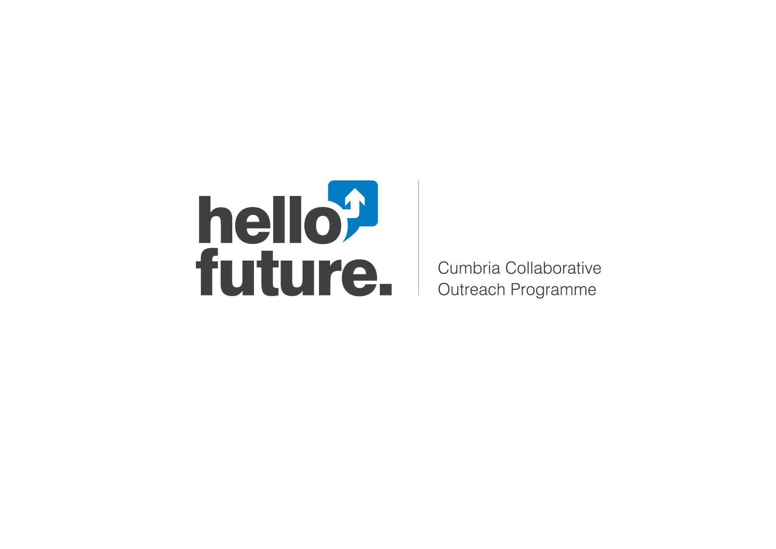

**Hello Future Cultural Trip and Community Experience 19_20**

|  |  |  |
| --- | --- | --- |
| **Background Information** | | |
| Name of partnership | Hello Future – Cumbria Collaborative Outreach Programme | |
| File name | N/a | *Please select if a separate report/output has also been submitted* |
| Date evaluation carried out | 7/3/2020 | |
| Format of material | Written into this template. | |
| **Characteristics Of Outreach Evaluated** | | |
| Activity type | Cultural Trip and Community Experience.  Community Activity – aligning with Visual Arts and Creative Industries as part of our remit to work with the Cumbria Local Enterprise Partnership. | |
| Brief description of activity being evaluated | Our package of cultural trips and community experiences are aligned to the Cumbria Careers Strategy developed by the Cumbria LEP. The strategy suggests there is a creative and cultural employment gap in Cumbria. In the CFE baseline survey Carlisle learners were most clear about the type of job they wanted to, when compared to learners in West Cumbria and Furness. Carlisle learners described wanting ‘creative’ and ‘cultural’ careers.  The intervention included group travel to Liverpool, museum visits, lunch, city exploration and urban form sketching.  (In light of the current Covid-19 restrictions the second part of this activity which was planned to include a Campus Visit and Masterclass with the same learners cannot take place in Phase 2 academic year 19/20) | |
| Length and intensity of activity | This was a one-day activity of 8.5hrs and of high intensity to Cumbrian target learners. | |
| Mode of delivery | Face-to-face delivered Hello Future Outreach Practitioners who are recent Graduates. | |
| Target group or groups | Target learners from Carlisle-based wards. Year 9 and 10 with an interest in Creative subjects. | |
| Total number of participants involved in the outreach activity | 5 learners (4 Target and 1 Non-Target learner).  Applications from non-target learners were declined, however one target learner would only attend if a non-target learner friend could also attend. | |
| **Outcomes Evaluated** | | |
| Description of key outcomes evaluated | Learner Outcomes for Cultural Trips and Community Experiences.   * The intervention activity will include ‘learning’ in a non-traditional education setting to develop target learner’s academic capital.   This outcome is measured by separating inquiry into what learner’s *enjoyed and learnt* post-intervention and measurement of the degree to which learners agreed or disagreed that they enjoyed *learning outside of the classroom*.     * Learners will develop new skills, apply existing skills to new tasks and challenge their existing their skill-sets (such as through participating in workshops at a level higher than their current educational level).   *Development and application of skills* will be measured before and after their participation through collecting data on the participating group’s ‘distance travelled’ by their agreement with the following statements; [1] ‘I developed new skills’, [2] ‘I applied my skills to new tasks’ and [3] ‘I like to challenge my skill-set’.   * Learners will have increased their individual confidence and developed positivity towards their future.   An *increase in confidence* will be measured through ‘distance travelled’ in terms of changes to confidence in ‘asking a question in a group’ and in ‘giving my [their] opinion to new people’ and their ‘willingness to ask others for help when I [they] need it’. Attitudes towards their future will measured by how positive they feel about their future, expressions of confidence in knowing the job they want to have and their capacity to feel supported in decision-making.   * The intervention activity aims to increase a learner’s social and cultural capital in relation to new environments. The rationale for this is that Cumbrian target learners are unlikely to have visited a city outside of Cumbria.   To overcome the accepted difficulties in understanding changes to an individual’s academic, social and cultural capital, the outcome will be measured in a number of exploratory ways.  [1] By gaining an understanding of whether the learner has previously *visited a city outside of Cumbria* prior to commencement of the intervention activity with all ‘cultural trip and community experiences’ including a visit to a city.   [2] Through understanding attitudinal changes towards *travel confidence* (identified in the CFE baseline survey 2017 as a barrier to HE for Cumbrian target learners and in a CCOP commissioned research project into rural and coastal HE barriers). Comparisons will be drawn between confidence in travelling with others and alone.   [3] In changes to a learner’s confidence in their *ability to problem solve in a new environment*.  [4] Application of new cultural capital gained by post-measurement of who a learner intends to tell about the experience (friends, parents/carers, other family members and teachers/advisors). We will evaluate the ‘reach’ of this application. The rationale behind this is that we aim for learner’s to move beyond telling friends and family to sharing their experience with teachers/advisors.   [5] Through gaining a pre-intervention understanding of whether the learner has previously visited a college campus, a university campus and/or experienced a work place environment. This will support our inquiry into encounters with HE and progression.   * Learners will have meaningful interactions with HE Alumni through individual face-to-face contact with a University graduate. The rationale for this is that in the local CFE dataset only a third of Cumbrian learners said that they knew someone who has been to University.   The outcome will be measured both pre and post-intervention. Before the activity we seek understanding of whether the learner has previously ‘*spoken to someone older with the same interests as you [them]’*. Post-intervention we ask learners whether they think they have had an interaction with a university graduate and what they learnt about further study through that specific interaction.   * The intervention aims to increase the likelihood of individual target learner progression to HE or a degree apprenticeship.   This is measured by analysis of the changes to learner’s likelihood of intention to progress to either HE or a Degree Apprenticeship both before and after the intervention. To support analysis of likelihood we also measure the extent to which learner’s feel they would *fit in at University*and whether prior to the intervention the learners have ‘met people the same age from different schools/colleges’ with the aim to emulate the experience of commencing higher education and the student life. | |
| **Methods Used To Evaluate Impact Of Intervention** | | |
| Type of approach | Mixed Qualitative and Quantitative Methods | |
| Rationale for approach | The methodology for using a mixed method approach is that Hello Future are collecting new data and each method will be weighted equally. Employing a mixed method approach strengthens the evidence base from which conclusions can be drawn. Adopting qualitative and quantitative approaches through the use of open and closed questions in both the ‘pre’ and ‘post’ learner and outreach practitioner observation provides richer insight through collecting data from two perspectives. ‘Pre’ and ‘post’ learner surveys enable study of the ‘distance travelled’ and progress made by learners through participation in the intervention activity against pre-determined outcomes. | |
| Data collection methods | ‘Pre’ and ‘post’ learner paper-based survey – see below. | Ethnographic observation by outreach practitioner. |
| Sampling methods and response rates | 5 female learners (4 Target and 1 Non-Target learner). 100% Response Rate. Mixed – Year 9 (3) and 10 (2).  Purposive Sample. | 1 Outreach Practitioner Observation |
| Timeframe for evaluation | Pre and post survey = 7/3/2020  Analysis = WC 9/3/2020 | Observation = 7/3/2020  Analysis = WC 9/3/2020 |
| Approach to data analysis | Each of Hello Future’s intervention activities are based on a Theory of Change which is informed by the development of a learner need progression pyramid. The pyramid identifies key areas of development for Cumbrian target learners to enable HE/Apprenticeship progression. The Theory of Change informs the progression framework and logic models which have pre-determined anticipated short and medium outcomes for each of the interventions formats and activities we deliver.  The learner survey questions are designed to measure the extent to which the intervention aims and anticipated learner outcomes have been met. Both the intervention aims and learner outcomes are pre-coded to inform the design of the data collection method and are used as the basis for coded thematic analysis. Open-ended questions provide an opportunity for unanticipated outcomes to emerge from the learners.  Statistical analysis is conducted on the quantitative data and thematic analysis on the qualitative data. These are both used to inform conclusions about the outreach interventions effectiveness in terms of skill development and encounters with HE.  An inductive approach was taken for the data analysis of the observation field notes. Analysis focused on the pre-coded themes of the learner outcomes, however when coding deductive analysis played a role in seeking to understand unexpected outcomes. The reason for this included the small sample group of the survey study and the Cumbrian specific nature of the intervention. | |
| **Results And Conclusions** | | |
|  | * *Learner Outcome: The intervention activity will include ‘learning’ in a non-traditional education setting to develop target learner’s academic capital.*   From the learner survey there was ‘no change’ in distance travelled towards there enjoyment of learning outside of the classroom. However the WP practitioner described how as the coach drove further into the centre of Liverpool the “*YP pointing at different buildings and asking each other “what building is that?” whilst looking out of the window*.” On approach to the Liver Building, it was observed how the YP approached staff by name for conversations “…“*Are we going there?* (pointing at Royal Liver Building tower) *I can’t wait!*” This provides evidence of enjoyment by the YP of learning in a non-traditional education setting.  During the intervention, time was allocated for the group to sketch in the city. Learner’s showed confidence in decision making and actively participated in the activity; “*two YP (Young Person/People) decided to sketch, two took photos and one YP used Polaroid camera to take photos. YP sketched seagull and YP trying to sketch a re-purposed London bus but it was too windy to draw. Resilience and problem-solving demonstrated here; taking pictures to draw later in the day, or soldiering on despite wind”.*   * *Learner Outcome: Learners will develop new skills, apply existing skills to new tasks and challenge their existing their skill-sets (such as through participating in workshops at a level higher than their current educational level).*   The intervention had a positive impact on application of skills to new tasks and in challenging their skillsets, however there was a negative impact on their “want to develop new skills”. One possible reason for this negative change is that the highly targeted nature of the intervention (pre-interest in Art) could have meant that learner’s had retained confidence in their current ‘creative’ skill-sets as a result of the intervention.   * *Learner Outcome:* Learners will have increased their individual confidence and developed positivity towards their future.   Learner’s reported a positive increase in [1] confidence in asking a question, [2] asking a question in a group, [3] asking others for help when needed, [4] in feeling supported to make decisions and [5] positivity about their future.  The WP practitioner identified that after initial group bonding on the coach journey, when they were asked whether they wanted to stop on route to Liverpool by staff, the learner’s collectively made the decision to stop. On the journey back from Liverpool to Carlisle, the practitioner observed how “*Gradually, all YP began sharing snacks and talking to each other (as a whole group) about when their birthdays are. Body language was very forward by this point, with a more ‘circular’ seating formation created*”. This contrasts greatly with the morning observation that of the school-attended spatial distance between the group “*three YP (school A) sat at the back of the coach, two YP (school B) sat further affront. Interacting in friendship groups but two schools not interacting with one another*”. Increased positivity about their future was exhibited particularly strongly by one target learner who, unprompted exclaimed to staff that “*I want to be an artist”; stating she also wanted to be an English teacher - “maybe I can do both*”.   * *Learner Outcome:* The intervention activity aims to increase a learner’s social and cultural capital in relation to new environments.   To overcome the known methodological challenges with measuring social and cultural capital development in individuals, CCOP (Hello Future) employed a quasi-experimental approach to measure the reach of their application of their experience, by asking who the learner intends to tell about it. The goal is that they intend to tell their teachers and advisors who can then support them to include their experience on progression applications such as personal statements. 80% of the group intend to tell their friends, all learners will tell their parents or carers, 60% will tell other family members and 40% will tell their teachers and advisors.    It has previously been identified that Cumbrian target learners are unlikely to have visited a city outside of Cumbria, therefore increasing travel confidence is an important barrier to overcome in terms of gaining social and cultural capital. This intervention had a positive impact on the learner’s confidence to travel in a group. There was no change to their confidence travelling alone. The latter is likely explained by limited opportunities for independent travel designed into this intervention.  There was a slight negative impact to their confidence in their ability to “*solve problems in a new place”*.Just before the journey back, staff initiated questions about whether the learners might like to live in Liverpool, they responded by saying *“no, it’s too big. I come from a little village, I think it would be too big of a change to move somewhere like this”.* This statement is highly representative of the target female cohort who we know from our baseline CFE analysis are likely to choose their future plans based on their ability to stay at home.  The following field note description of an interaction between learners, staff and the coach driver provides insight into the limited geographical knowledge of Year 9 and 10 target Cumbrian learners when discussing where the North/South divide in the UK is.  “*Staff asked: “Where do you think the North South divide is?”. Non-CCOP learner replied with “Birmingham is the south”. When met with hesitancy, Staff asked “what about Manchester? Would you consider that the North?” A couple of learners replied with “Where’s Manchester?”…. I wondered if they were unsure of where Cumbria was located on the UK map and whether this was something they had considered before as an important aspect of their identity*”.  The positive impact of this type of cultural trip and community experience can be observed in the transference of cultural-capital related skills between learners. The WP practitioner observed how one YP “*was talking about a painting whilst touching the descriptor plaque*. [Another] *YP said “don’t touch that!” and fixed plaque to its original position – learners adopting and teaching each other what they consider to be ‘unwritten rules’ of gallery etiquette.* In the ‘post’ survey, learners described visiting the Liver Building as the part they learnt the most from.   * *Learner Outcome:* Learners will have meaningful interactions with HE Alumni through individual face-to-face contact with a University graduate.   In the post-survey, 60% of the group described having spoken to someone who had been to University. The other 40% were unsure whether they had or not rather than stating they hadn’t. Those who described having met a ‘University Graduate’ learnt that “*Art is used in many industries*” and that ‘*there is lots to learn’*. One learner who was unsure about whether they had interacted with a ‘University Graduate’ had still learnt that “*there’s more options*” to further study. The intervention produced no change to their confidence in thinking they would fit in at university. The second (now postponed) part of this intervention with the same learner group would include a HE campus visit.     * *Learner Outcome:* The intervention aims to increase the likelihood of individual target learner progression to HE or a degree apprenticeship.     Although all learners in the group were either unsure or very unlikely to pursue a degree apprenticeship, HE intentions were more positive. 60% are very likely to pursue University and 40% unsure. 40% are likely to pursue a creative career. The practitioner record of an interaction between staff and learner’s provides narrative insight into the two year 10’s decision not pursue Art as a subject at GCSE therefore limiting further study options, “…*they confirmed that they enjoyed art but did not choose it as an option for their GCSEs. When asked why, they explained that their teacher was a key reason as she did not cover the type of art that they enjoy in her subjects*”. | |
| Challenges/ limitations of evaluation | A small learner sample size. | |
| Impact achieved | *Positive*  *Negative*  *Mixed impact*  *Too early to say*  *No impact*  *If demonstrable impact is shown please provide further details:* | |
| Contribution or attribution? | The mixed but predominantly positive impact can thus far only be considered contributory in the short term. A further investigation into this learner group’s post-16 and 18 choices would be needed to be able to attribute impact directly to this intervention, however we are confident that skill application has occurred and the facilitation of rich social and cultural capital building opportunities will support a learner’s capacity to build academic capital to progress. | |
| **Self- assessment** | | |
| Self-assessment of type of evidence | Type 1 – Narrative  Type 2 – Empirical Enquiry  Type 3 – Causal  *Please refer to section 4 of the guidance document for further information.* | |
| Self-assessment of strength of evidence | Weaker  Average  Stronger  *Please refer to section 4 of the guidance document for further information.* | |

|  |  |  |
| --- | --- | --- |
| **I consent to the information contained in this document, including separate reports/outputs) to be shared with TASO** |  | * |
| **I do not consent to the information contained in this document, including separate reports/outputs) to be shared with TASO** |  |  |

*\*CCOP is one of the smaller UniConnect Programmes with a target cohort of 5540 learners. We work with all 29 schools and colleges in Carlisle, Barrow-in-Furness and West Cumbria and many of our interventions are highly targeted. Therefore we ask that no school or college names are shared with TASO.*

For further clarification please email the Data and Evaluation Manager - lucy.wright@cumbria.ac.uk